


NATIONAL CERTIFICATE (VOCATIONAL)

FUNDAMENTALS

MATHEMATICS

NQF LEVEL 2
7-P2 (V1)
TASK:
11/09/ 2026

DATE: DURATION:
3 HOURS

100
15
MARKS: ICASS weighting:

This question paper consists of 9 pages including a formula sheet.

SUBJECT OUTCOMES BEING ASSESSED:

SUBJECT OUTCOMES | LEARNING OUTCOMES
Topic 3: Space, Shape& Measurement  Topic 4: Data Handling | 3.1.1 – 3.6.4  4.1.1 – 4.2.7

INSTRUCTIONS AND INFORMATION

1.  2.  3.  4.  5.  6 | Read ALL the questions carefully.  Answer ALL the questions.  Number the answers correctly according to the numbering system used in this question paper.  Write neatly and legibly.  Round off answers to THREE decimal places, unless stated differently  All work you do not want to be marked must be clearly crossed out.

QUESTION 1

1.1 | Define each of the following terms used in data handling:

 | 1.1.1 | Mean |  | (2)

 | 1.1.2 | Mode |  | (2)

 | 1.1.3 | Median |  | (2)

1.2 | The following are the Mathematics marks of 20 NCV Level 2 students in a TVET  college:

15 | 39 | 50 | 28 | 56 | 34 | 57 | 37 | 30 | 57
50 | 57 | 35 | 47 | 57 | 37 | 44 | 55 | 57 | 25

1.2.1 | Construct a stem-and-leaf diagram. | (5)

1.2.2 | Determine the mean of the given data. | (2)

1.2.3 | Determine the median value of the given data. | (2)

 |  | 81 | 77 | 67 | 75 | 88 | 80
 |  | 71 | 66 | 65 | 72 | 74 | 66
1.3.1 | Determine the lower quartile. |  |  |  |  |  |  |  | (2)

1.3.2 | Determine the upper quartile. | (2)

1.3.3 | Determine the interquartile range. | (2)

1.3.4 | Determine the range of the data. | (1)

1.3.5 | Determine the 68th percentile of the data. | (3)

1.4 The following data shows the different types of sports the learners in a TVET college
support:
CRICKET | TENNIS | TENNIS | GOLF
CRICKET | HOCKEY | HOCKEY | TENNIS
SOCCER | CRICKET | SOCCER | TENNIS
SOCCER | GOLF | TENNIS | HOCKEY
HOCKEY | SOCCER | HOCKEY | SOCCER
HOCKEY | CRICKET | SOCCER | HOCKEY
GOLF | HOCKEY | GOLF | HOCKEY
SOCCER | CRICKET | TENNIS | SOCCER
GOLF | TENNIS | CRICKET | TENNIS
SOCCER | SOCCER | SOCCER | SOCCER

1.4.1 | Use the given data to complete the tally and frequency table on ANSWER  SHEET A (attached). | (5)

1.4.2 | Draw a bar graph on ANSWER SHEET A (attached) using the given  information. | (5)
1.4.3 | Use the frequency table to construct a pie chart as degrees on  ANSWER SHEET B (attached). Show all calculations. | (5)
 |  | [40]

QUESTION 2

2.1 | The sketch below shows a concrete beam in the shape of a rectangular prism with a length of 12 cm, a width of 8 cm and a height of 6 cm. The beam is to rest on two closed cylinders, each having a diameter of 3 cm and a height of 8 cm.  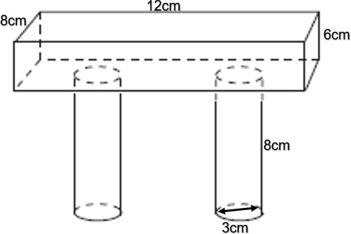

2.1.1 | Determine the surface area of one closed cylinder. | (3)

2.1.2 | Calculate the total volume of concrete needed to make the beam and the pillar . | (7)

2.2 | 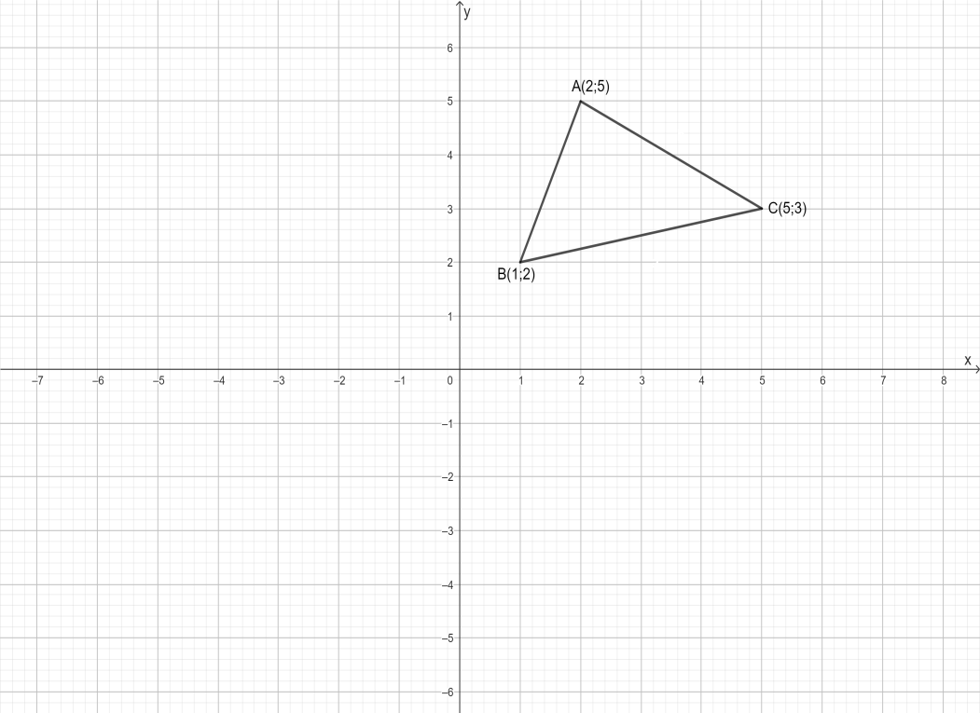  A triangle with vertices A (2; 5), B (1; 2) and C (5; 3) is shown below.

2.2 | The figure below shows ∆ABC with vertices A (−1; 2), B (4 ; 2) and C (3; 5).

2.2.1 | Determine the co-ordinates of Á if ∆ABC is reflected about the y-axis | (2)

2.2.2 | Determine the co-ordinates of B́ if ∆ABC is translated 2 𝑢𝑛𝑖𝑡𝑠 down and 1 units to the left. | (2)

2.2.3 | Determine the co-ordinates of Ć if ∆ABC is reflected about the x-axis | (2)

2.3 | The figure below shows ∆ABC with vertices A (−1; 2), B (4 ; 2) and C (3; 5).

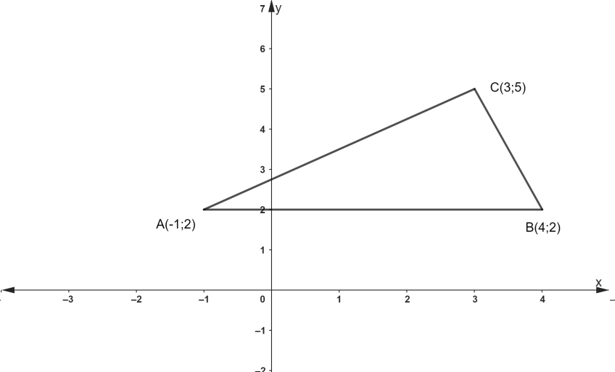

2.3.1 | Calculate the length of line segment AC | (3)

2.3.2 | Determine the length of line segment B | (3)
2.3,3 | Calculate the co-ordinate of the midpoint of AC | (3)

2.3.4 | Determine the angle of inclination of line segment AC | (5)

[30]

QUESTION 3

3.1 | 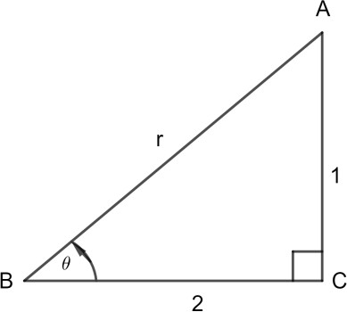  Consider the following diagram. In ∆ABC, AB = r , AC = 1 and BC = 2. Determine the values of the following:

 | 3.1.1 | The value of r |  | (3)

 | 3.1.2 | tan𝜃 |  | (2)

 | 3.1.3 | cos𝜃 |  | (2)

 | 3.1.4 | sin𝜃 |  | (2)

 | 3.1.5 | 3𝑐𝑜𝑠𝜃 + 2sin𝜃 |  | (3)

2.2

3.2 | Given 𝑓(𝑥) = 2 cos 𝑥 and 𝑔(𝑥) = sin 𝑥 +1 where 0^{𝑜} ≤ 𝑥 ≤ 360^{𝑜} .

.
 | 3.2.1 | On ADDENDUM C (attached), sketch 𝑓(𝑥) and 𝑔(𝑥) on the same set of axes. By using table method |  | (10)

 | 3.2.2 | What is the amplitude of f(x) ? |  | (2)

 | 3.2.3 | What is the period of g(x) ? |  | (2)

 | 3.2.4 | What is the domain and range of g(x)? |  | (2)
 | 3.2.5 | Are the graphs continuous or discontinuous? |  | (2)
 | TOTAL |  |  | (30)

GRAND TOTAL: (100)

EXAMINATION NUMBER

ADDENDUM A

1.4.1

SPORTS | TALLY | FREQUENCY
Cricket | 1111 1 | 6
 | TOTAL:

(5)

1.4.2
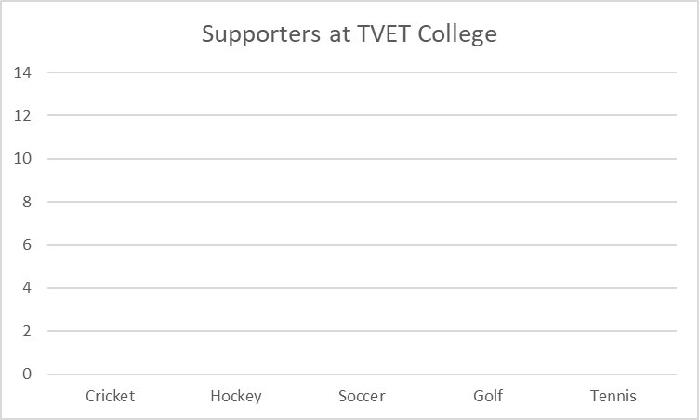
(5)

EXAMINATION NUMBER:

ADDENDUM B

1.4.3
SPORTS | DEGREE

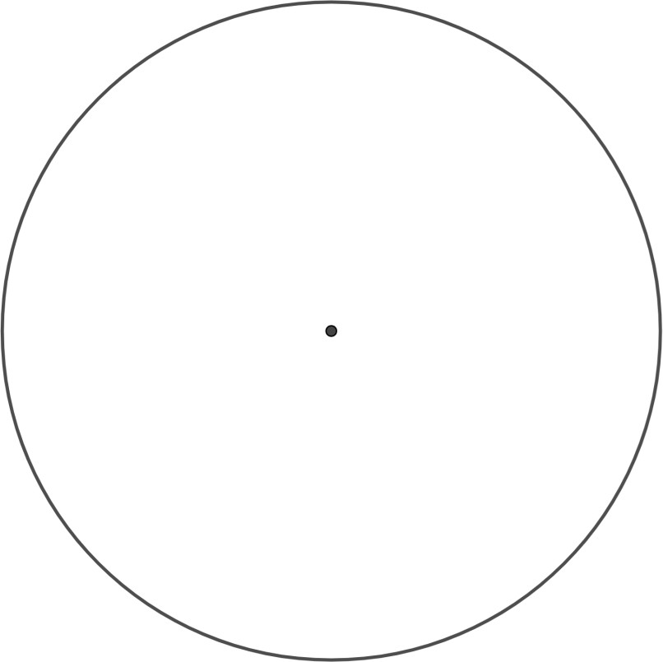

(5)

EXAMINATION NUMBER:

ADDENDUM C
3.2 | 3.2.1

x | 0° | 30° | 60° | 90° | 120° | 150° | 180° | 210° | 240° | 270° | 300° | 330° | 360°
f (x) = sin x +1
g(x) = 2cos x

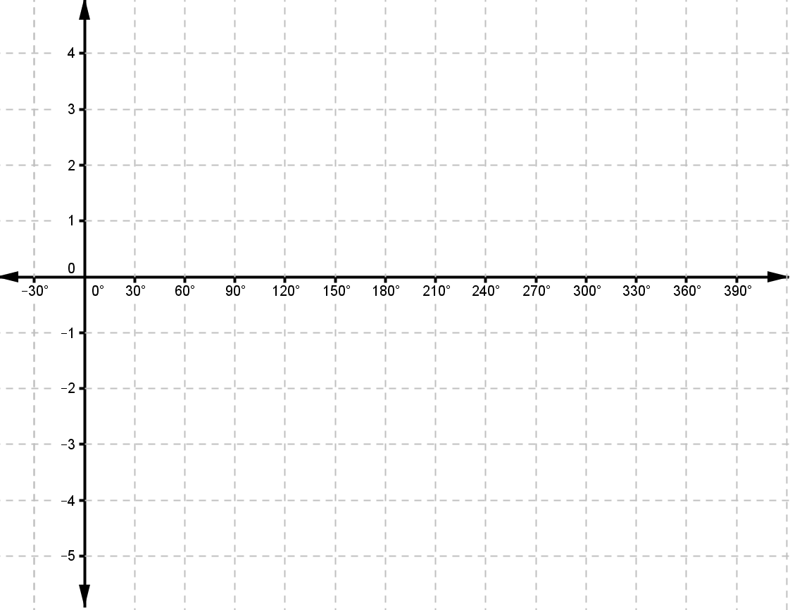

(10)

